**Comprehensive project using Microsoft word**

Submitted By:

Name: Al-Fahariul

Batch: 40

Roll: 01-040-02

12/7/2024

Anchor Cement

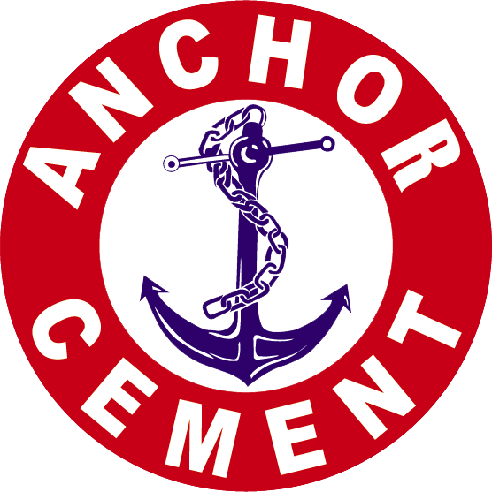

Table of Contents

1 Establish industry-leading standards for modern technology on a regular basis to meet customer needs for cutting-edge products and services. 9

2 Contribute to the nation's economic expansion and infrastructural development. 9

3 Achieve the best possible competitive advantage in our target markets by producing high-quality goods and working as efficiently as possible. 9

4 Collaborate with the best suppliers to increase value for the company and its customers. 9

5 Become recognized as an exclusive, cherished institution and a candidate's first choice. 9

6 Provide a diverse array of job options, outstanding pay and benefits, chances for training and growth, and a comfortable work atmosphere. 9

7 Employees will be fully integrated into our network and given the flexibility to flourish at every level. 9

8 Continually demonstrate our commitment to environmental sustainability and proactively participate in Corporate Social Responsibility (CSR) initiatives within our sphere of influence. 9

9 Attain enduring financial prosperity 9

10 Provide secure investment prospects for the country. 9

11 Enter new market segments to increase variety and flexibility. 9

12 Enhance administrative and organizational procedures to regularly evaluate all business lines and develop best practices for the industry. 9

13 Export to generate significant overseas revenue. 9

[**Anchor Cement**](https://www.olympiccement.com/investor-relations/annual-reports)

Cement import and trade has been a part of Rahman Traders' (Associate Concern of Olympic Cement Ltd.) business since 1974. Rahman Traders invested in the cement factory as part of an industrial venture in 1999. Olympic Cement Ltd. began operations on July 29, 1999, with the goal of supplying premium cement to both domestic and international markets in support of the nation's economic growth. It is situated on the Kirtonkhola River's bank at Rupatali, Barisal.

One of Bangladesh's top producers of cement is Olympic Cement Ltd. As a corporation with ISO certification, we began operations on February 18, 2002, producing 800 metric tons per day. In 2010, we added another 800 metric tons per day to our volume, and in 2015, we added a further 2400 metric tons per day, bringing our total output to the current level.4000MT of capacity per day. Management's dedication to supplying top-notch cement across the nation. It goes under the moniker "Anchor Cement." With its superior quality, punctual delivery, and top-notch customer support, Anchor Cement quickly establishes a solid position in both the local and international markets. Anchor Cement's distinctive brand image has helped it become more well-known.

amid a sizable populace of regular users.With confidence, people started using Anchor Cement in a range of big and small-scale building projects.

The newest machinery and technologies available today are found in our facility, including a V separator, cyclone separator, O-sepa separator, roller press, ball mill, etc. Skilled technicians, engineers, and chemists operate it. We are able to produce cement of superior quality with this production technology. It adheres to a practice of constant improvement to guarantee client happiness.

The building sector, which uses the cement industry as fuel, contributes around 10% of Bangladesh's national income. Anchor Cement has emerged as the trust symbol in this road march.

We will generate long-term economic value for our shareholders by implementing a successful business plan.

Devoted to contributing to the betterment of the community by creating jobs, aiding local projects, and being a responsible corporate citizen.Use state-of-the-art technology, offer a wide selection of items, and go above and beyond to satisfy their needs in order to deliver excellent customer service. Put your faith in the inherent worth of your employees. Together, assess each person's unique experiences, viewpoints, aptitudes, and competencies at all professional levels.

* **Accountability**

It is our duty to provide excellent products and services while adhering to strict legal requirements and ethical business practices.

* **Ability**

We are able to take on the responsibility of achieving our goals and keeping our commitments. We make new decisions and prepare for the future. We have the flexibility to swiftly adapt and modify our strategy as necessary.

* **Keep Your Word**

We emphasize morals and excellence in whatever we do. We believe actions more than words. Our whole focus is on making sure our clients are satisfied.

* **Show respect**

We respect our investors, clients, and other stakeholders, and we make every effort to satisfy their needs. We consistently appreciate the suggestions and viewpoints from our stakeholders. We are kind, accommodating, and open.

* **Be Respectful**

We respect our customers, investors, and other stakeholders, and we make every effort to satisfy their needs. We consistently appreciate the suggestions and viewpoints from our stakeholders. We are kind, accommodating, and open.

**Customer Service of Anchor Cement:**

Our concern is the present compliance issue. We are therefore totally dedicated to giving our customers value before, during, and even after the transaction. We work really hard for your advantage. As a value-added service, we offer outstanding technical assistance, first-rate logistics, and outstanding customer service for our bespoke items and innovative solutions.

We are always ready to provide complete logistical support for managing each phase. There is enough transit options, including river and road. To carry our brands, Olympic Shipping Lines has a large fleet of cargo ships and trawlers, and our own transportation firm has a big fleet of vehicles, covered vans, and lorries. Because of this, our valued clients may easily get fresh, premium cement anytime they want, no matter where they are in the nation or abroad.

We gladly answer all calls, emails, and letter correspondence. For each job we take on, we provide both on- and off-site assistance. We bring together engineering, creativity, technology, expertise, and quality procedures to create a broad range of solutions.

**Products of Anchor Cement:**

**Anchor Portland Cement**

Portland cement is sometimes known as Ordinary Portland Cement (OPC). Following a complete combination of calcareous and argillaceous materials, they are burnt at temperatures as high as 1450 degrees Celsius to produce clinker, or calcined product. This is then crushed to the required fineness and mixed with gypsum to generate cement. This cement is made up of a finely powdered blend of silicates and calcium aluminates that react chemically with water to set and hydrate. When combined with water, Anchor OPC, a finely crushed inorganic substance, makes a paste that uses hydration to set and solidify.

responses. It keeps its stability and strength underwater after hardening. When aggregates and water are combined, concrete is created.

An Olympic OPC contains both clinker (96–100%) and gypsum (0.4–4%). Its independent manufacturing lines, cement storage silos, and automated rotary packing machinery are further unique features of its production plant.

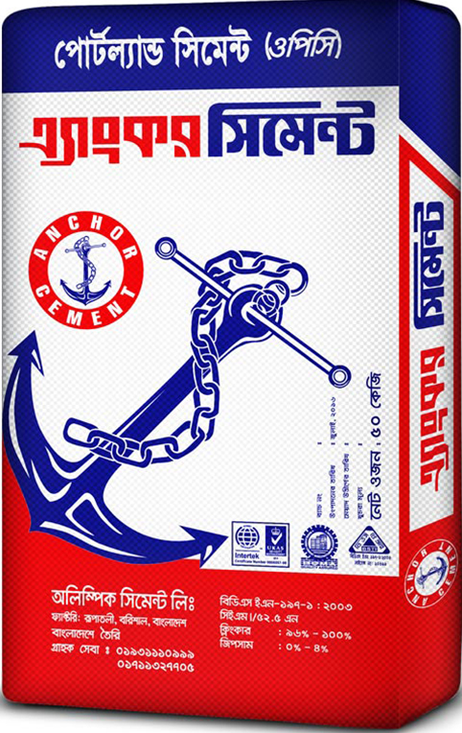

**Anchor Portland Composite Cement (PCC):**

Clinker, gypsum, and premium supplemental cementations (SCM) such fly ash, limestone, silica fame, ground granulated blast furnace slag, and fly ash make up Anchor Portland Compound Cement. The firm is qualified in accordance with ASTM and BIS standards since it is made in compliance with European standards, BDSEN 197-1:2003. In 2005, Olympic Cement Ltd. released PCC. Anchor Portland Compound's manufacturing design is more workable and has more long-term strength. When time passes and the concrete's density rises, PCC's long-term strength is enhanced. The longer lifespan and durability of the construction are enhanced by the concrete's increased density.

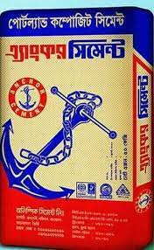

**Portland Composite Cement (PCC):**

Use an anchor cement Clinker, gypsum, and premium supplemental cementations (SCM) such fly ash, limestone, silica fame, ground granulated blast furnace slag, and fly ash make up Anchor Portland Compound Cement. Because it is produced in compliance with European regulations BDSEN 197-1:2003, the firm is accredited by ASTM and BIS. In 2005, Olympic Cement Ltd. released PCC. Anchor Portland Compound's manufacturing design is more workable and has more long-term strength. When time passes and the concrete's density rises, PCC's long-term strength is enhanced. The longer lifespan and durability of the construction are enhanced by the concrete's increased density.

As regular cement hydrates, calcium oxide (CaO) and calcium silicate hydrate (CSH) are produced as byproducts. The weak link in the process that prevents the material from becoming stronger is calcium oxide (CaO), which is why it is inappropriate for use in concrete. PFA has a higher amount of reactive silica and alumina-containing slag, which helps convert (CaO) into CSH to boost strength.

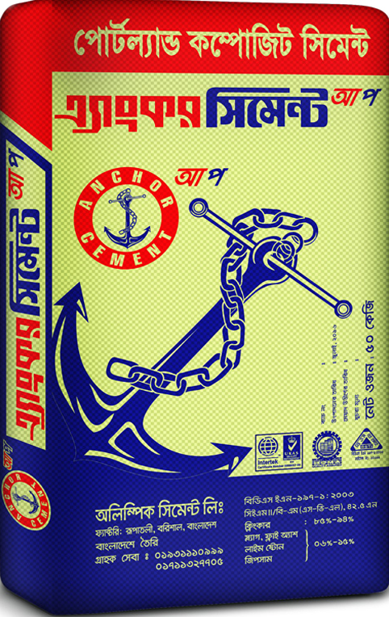

**Business Plan of Anchor Cement:**

Market Research and Feasibility Study

Business setup

Production process setup

Production process

Quality Assurance

Logistics and Distribution

Marketing and sales

Customer Support and Feedback

Growth and expansion

**Goals of the Company**

# Establish industry-leading standards for modern technology on a regular basis to meet customer needs for cutting-edge products and services.

# Contribute to the nation's economic expansion and infrastructural development.

# Achieve the best possible competitive advantage in our target markets by producing high-quality goods and working as efficiently as possible.

# Collaborate with the best suppliers to increase value for the company and its customers.

# Become recognized as an exclusive, cherished institution and a candidate's first choice.

# Provide a diverse array of job options, outstanding pay and benefits, chances for training and growth, and a comfortable work atmosphere.

# Employees will be fully integrated into our network and given the flexibility to flourish at every level.

# Continually demonstrate our commitment to environmental sustainability and proactively participate in Corporate Social Responsibility (CSR) initiatives within our sphere of influence.

# Attain enduring financial prosperity

# Provide secure investment prospects for the country.

# Enter new market segments to increase variety and flexibility.

# Enhance administrative and organizational procedures to regularly evaluate all business lines and develop best practices for the industry.

# Export to generate significant overseas revenue.

**Sales and cost statistics using tables and chart**

|  |  |  |  |
| --- | --- | --- | --- |
| Month | Sales Revenue | Production cost | Profit |
| January | 60000 | 20000 | 40000 |
| February | 100000 | 40000 | 60000 |
| March | 70000 | 30000 | 40000 |
| April | 80000 | 30000 | 50000 |
| May | 65000 | 10000 | 55000 |
| June | 50000 | 15000 | 35000 |
| July | 75000 | 20000 | 55000 |
| August | 50000 | 25000 | 25000 |
| September | 90000 | 10000 | 80000 |
| October | 85000 | 15000 | 70000 |
| November | 95000 | 20000 | 75000 |
| December | 80000 | 15000 | 65000 |